Monthly and Weekly Plans
January  1 | - 5th. New Year Event  - 12th. Japanese Cartoons  - 19th. Let’s make Miso-soup  - 26th. Coming of Age Day | 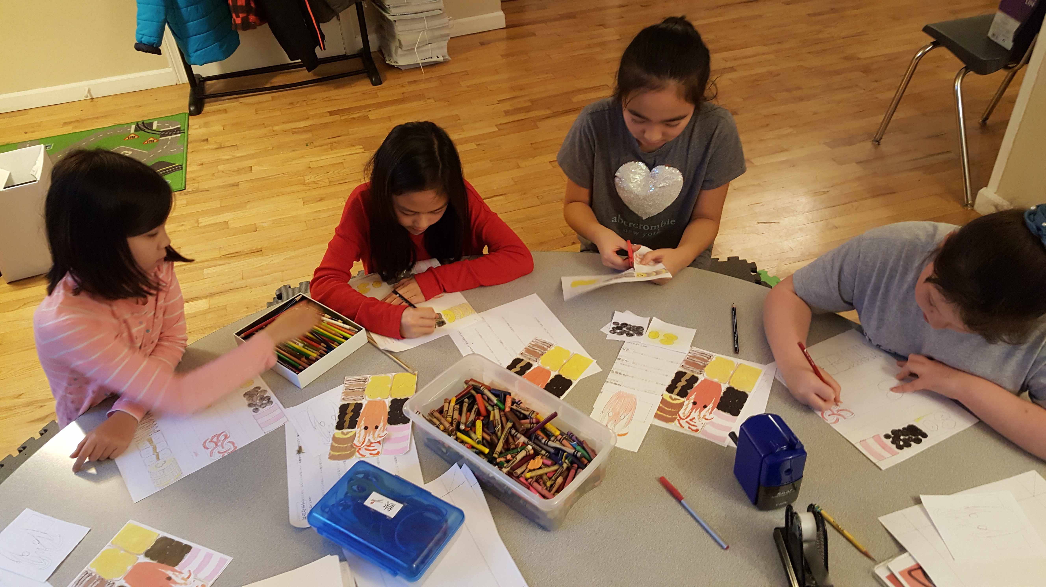
February  2 | - 2nd.Bean-throwing Ceremony  - 9th. Kanji Master  - 23rd. Proverb, Saying | 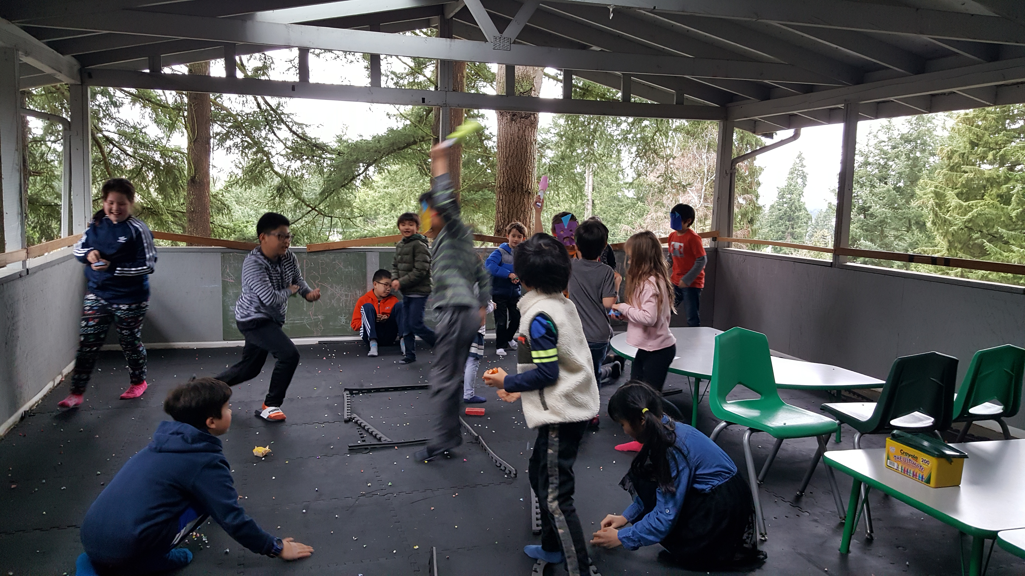
March  3 | - 2nd. Girl’s day Festival  - 9th. Hiragana  - 16th.Origami  - 23rd. Cherry blossom Viewing and Making Rice balls | 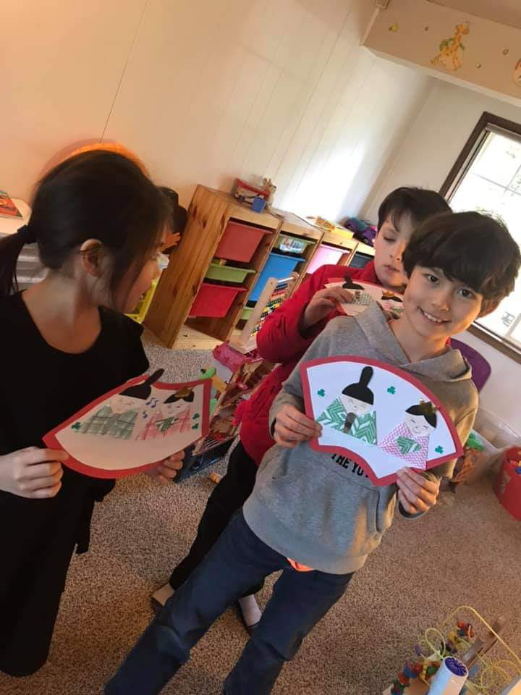
April  4 | - 6th. Hiragana  - 13rd. Rhetorical techniques (Omomatopeia)  - 20th. Tongue Twister  - 27th. Story Times (Japanese fairy tale) | 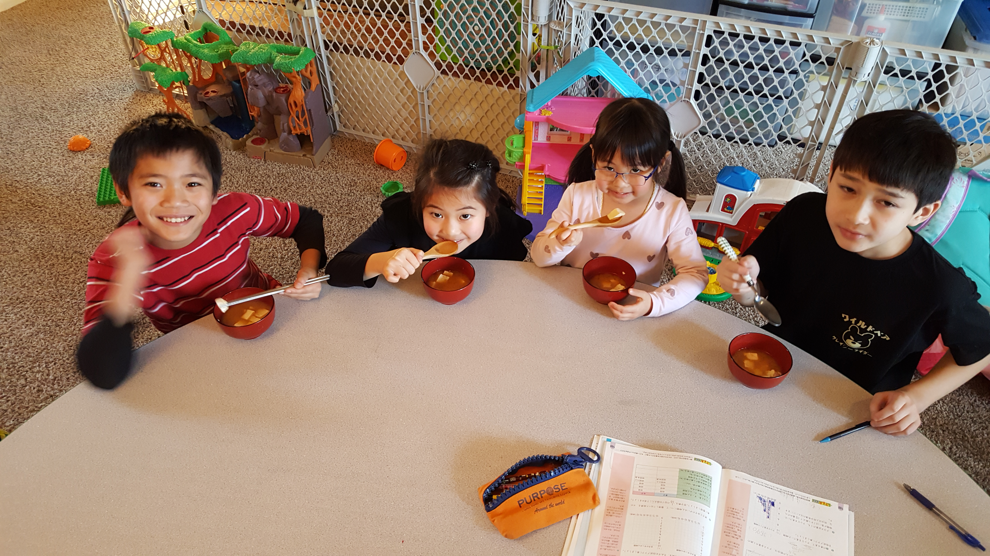
May  5 | - 4th. Children’s day (Boy’s day)  - 11th. Katakana  - 18th. Story Times (Japanese fairy tale)  - 25th. Sewing | 